Hi Sunny –

Let’s pause the animation chart for now and move onto the next. There are only a few more charts that I’m hoping to make, so I think it makes sense to finish all of them before we revisit details of the others.

The next chart I would like to make is a heatmap similar to the following example:

<https://www.amcharts.com/demos/heat-map-with-legend/>

For this chart, I have created a new database table named “heatmap”. There are five columns in the table:

Kde_score, quadrant1, quadrant2, quadrant3, quadrant4

The general format I am going for is outlined below:

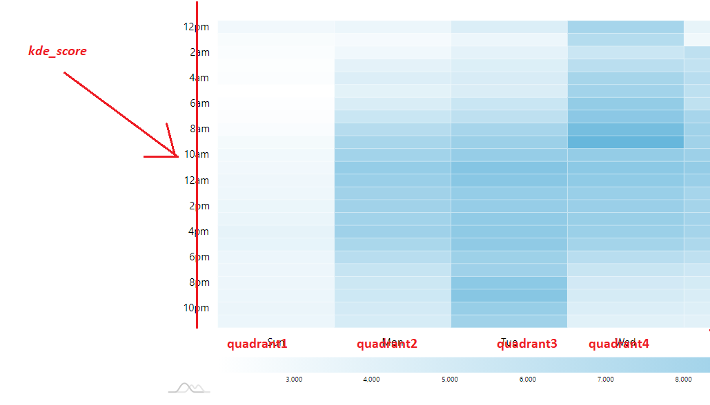

Each quadrant will have its own section and there will be only four sections total.

Formatting of numbers –

The numbers in each cell in the table are meant to represent a multiplier number. For example, a value of 3.2322 would be interpreted as “3.23x”. Do you think its possible to have the legend and tool tip reflect this? (similar to how we have been reformatting percents to reflect a more readable/interpretable value)

Colors –

Instead of only blue and white… do you think its possible to have the coloration be:  
red 🡪 white 🡪 green

The idea being, that a value of 0 would be white… while any positive value would be colored green (with higher values being progressively deeper/brighter shades of green)… and negative values would be red with the lower values being progressively more red.